Bug report 1 - SHEIN
  - Marita-Thuri Maria

Title:
Non-black bag is displayed in search results for “black bag”
Summary:
When searching for “black bag” on the SHEIN mobile website, the search results include a red/burgundy bag that does not match the searched color.
Environment:
SHEIN mobile website, Chrome – iPhone, iOS 26.6.1
Preconditions:
  - User has access to the SHEIN mobile website.
  - No specific filters are required.
Steps:
  - Open the SHEIN mobile website.
  - Tap the search bar.
  - Enter “black bag”.
  - Submit the search.
  - Scroll through the displayed search results.
  - Observe the red/burgundy bag displayed among the results.
Expected result:
The search results should display products relevant to the “black bag” search query, including bags available in black.
Actual result:
A red/burgundy bag with no black color option is displayed among the search results.
Severity:
Low
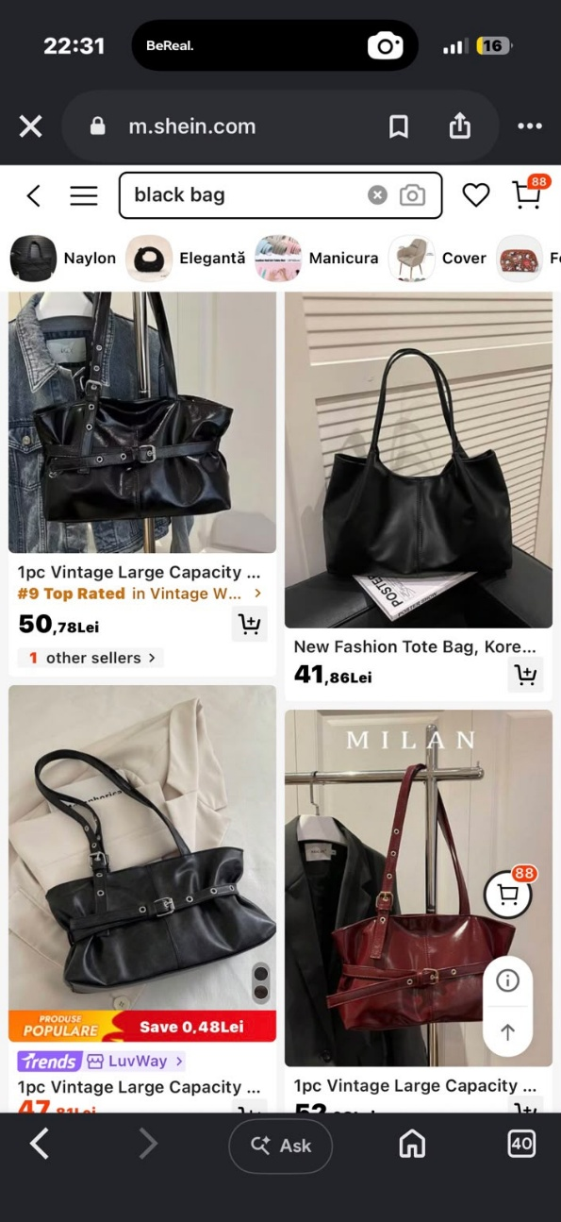
Evidence:

Bug report 2 - SHEIN
  - Marita-Thuri Maria

Title:
SHEIN mobile website does not adapt to full screen width in landscape orientation.
Summary:
When the SHEIN mobile website is viewed in landscape orientation, the page content remains constrained to the left side of the screen instead of adapting to the available viewport width. A large unused blank area is displayed on the right side.
Environment:
SHEIN mobile website, Chrome – iPhone, iOS 26.6.1 – Landscape orientation
Preconditions:
  - User has access to the SHEIN mobile website.
  - Device is initially used in portrait orientation.
Steps:
  - Open the SHEIN mobile website.
  - Navigate to the homepage.
  - Rotate the mobile device from portrait to landscape orientation.
  - Observe the page layout.
Expected result:
The website should responsively adapt its layout to the landscape screen size and correctly use the available viewport width.
Actual result:
The website content occupies only the left portion of the screen, while a large blank area is displayed on the right side.
Severity:
Medium
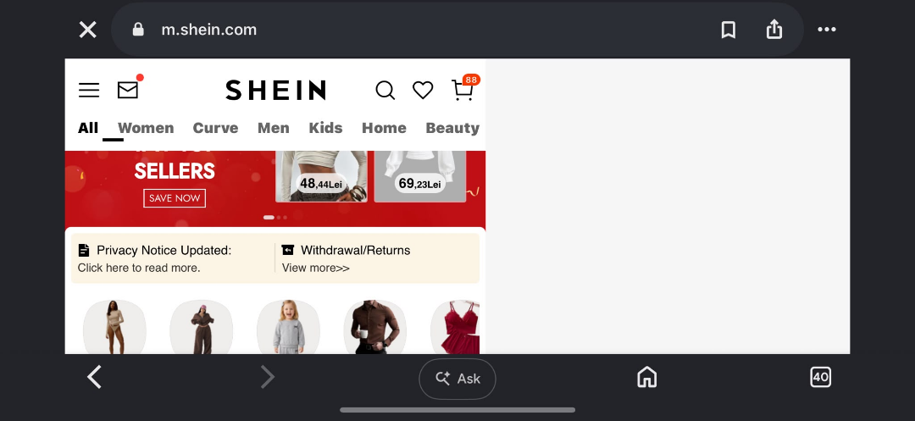
Evidence:

Bug report 3 - SHEIN
  - Marita-Thuri Maria

Title:
Men’s product is incorrectly labeled as “Women” in the product title
Summary:
A product listed correctly under the Men’s Plus Size Pants category contains the word “Women” in its product title, although the product is categorized and presented as men’s product.
Environment:
Desktop – Windows 10 – Google Chrome
Preconditions:
  - User has access to the SHEIN website.
  - SHEIN website is successfully loaded.
  - User is browsing the Men section.
  - No login required
Steps:
- Open the SHEIN website.
- Navigate to Men -> Men Plus Size Clothing.
- Select Men Plus Size Bottoms -> Men Plus Size Pants.
- Locate the VENTUSAIL Plus Size pants
- Observe the product title.
Expected result:
The product title should correctly identify the item as a men’s product or contain no incorrect gender designation.
Actual result:
The men’s product is labeled “Plus Size Women” in its title.
Severity:
Low
Evidence:
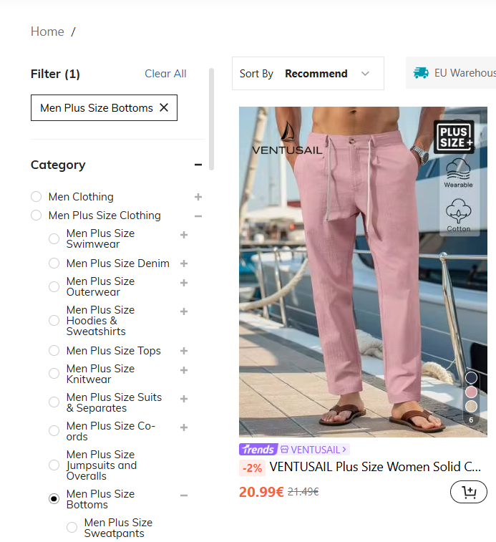

Test Case 1 – SHEIN
  - Marita-Thuri Maria

Test Case ID: 001
Title:
Verify product search using a valid keyword
Environment:
Desktop – Windows 10 – Google Chrome
Preconditions:
- SHEIN website is accessible.
- User is on the SHEIN homepage.
- Internet connection is available.
- User does not need to be logged in.
Test Steps:
- Click on the search bar.
- Enter ‘dress’.
- Press Enter/Search.
- Observe the search results page.
Expected Result:
The search results page should be displayed and should contain products relevant to the entered search term.
Actual Result:
The search results page is displayed and products related to dresses are shown.

Test Case 2 – SHEIN
  - Marita-Thuri Maria

Test Case ID: 002
Title:
Verify that a product can be added to the shopping cart
Environment:
Desktop – Windows 10 – Google Chrome
Preconditions:
- SHEIN website is accessible.
- A product that is currently in stock is available.
- User is on the product details page.
- Required product options such as size, color, quantity can be selected

Test Steps:
- Open a product.
- Select an available size, if required.
- Select an available color, if required.
- Click ‘Add to bag’.
- Open the shopping cart.
Expected Result:
The selected product should be successfully added to the shopping cart with the correct product, size, color, quantity and price.
Actual Result:
The selected product is displayed in the shopping cart with the selected options.

Test Case 3 – SHEIN
  - Marita-Thuri Maria

Test Case ID: 003
Title:
Verify that a product can be added to the Wishlist
Environment:
Desktop – Windows 10 – Google Chrome
Preconditions:
- SHEIN website is accessible.
- User is logged into a valid SHEIN account.
- User is viewing an available product.

Test Steps:
- Open a product page.
- Click the heart/Wishlist icon.
- Navigate to the Wishlist/Favorites section.
- Locate the selected product.
Expected Result:
The selected product should be added to the user’s Wishlist and should appear in the Wishlist section.
Actual Result:
The selected product appears correctly in the Wishlist.

  - New test design techniques:
1.Use case test technique:
A test design technique that uses test scenarios from realistic interactions between a user and the system. The focus is completely a user goal rather than testing an individual function in isolation.
One use case tested on SHEIN was searching for a specific type of product. I searched for “black bag” with the goal of finding black bags and checked the results to see if they matched what I was searching for. While going through the products, I noticed that one of the bags did not match the searched color, which showed an issue with the search results.

2.Compatibility testing:
A test design technique that checks whether a website works and displays correctly across different devices, browsers, operating systems, screen sizes or orientations.
I used compatibility testing to check how the SHEIN website behaves on different devices and screen orientations. While testing the website on an iPhone in landscape mode, I noticed that the page did not adapt correctly to the screen size and a large blank area appeared on the right side.

